The objective of this document is to provide technical specifications related to data supplied by the SIIQ. This data may be published on a Website or in various publications.

In addition to this document, we recommend you to refer to the SIIQ.mdb data template (Access format). You will find the field definition for each table.

1. File format

Data is sent on a daily basis by FTP (active mode only) in a file named “COMPAGNIEABCYYYYMMDD.zip”. This file includes documents with a .txt extension, containing data to be imported. Each file corresponds to a table (please see SIIQ.mdb data template).

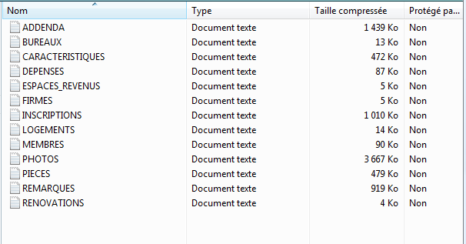

Fields are separated by commas and data can be imported in the database of your choice (MySQL, Oracle, Access, etc.)

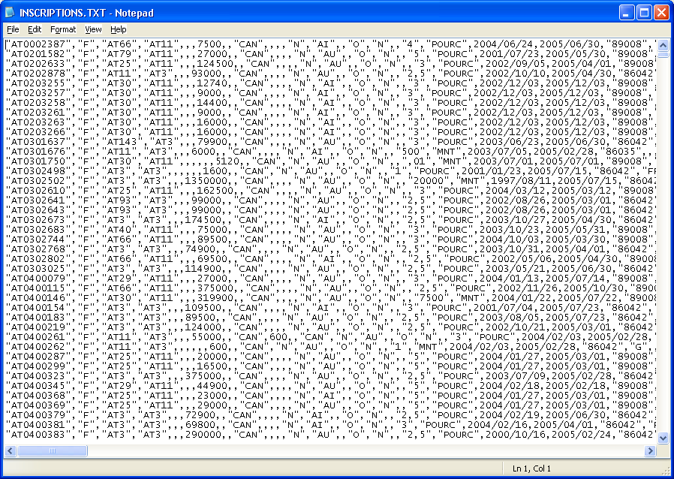

2. Dictionary tables

In the first mailing, you will receive dictionary tables. You can consult the data from these tables in the SIIQ.mdb data template. These tables contain fixed values in reference to value tables:

REGIONS
MUNICIPALITES
QUARTIERS
GENRES_PROPRIETES
TYPE_CARACTERISTIQUES
SOUS_TYPE_CARACTERISTIQUES
TYPES_BANNIERES
VALEURS_FIXES

When the FCIQ edits those tables, they will be returned to you. It is important to update those tables in order to ensure data integrity.

3. Value tables

On a daily basis, you will receive all data related to your clients’ active listings. This data is inserted in value tables:

ADDENDA
BUREAUX
CARACTERISTIQUES
DEPENSES
ESPACES_REVENUS
FIRMES
INSCRIPTIONS
LOGEMENTS
MEMBRES
PHOTOS
PIECES
REMARQUES
RENOVATIONS

Please note that, on a daily basis, you must “overwrite” data with the new values since your clients’ active listings are sent to you everyday, edited or not.

4. Photos

Listing photos are transmitted using a specific link. Do not use the attached links on any other websites. With the aid of these links, you will need to recuperate each photo and save them directly on your server. For performance purposes, it is recommended that you synchronize using these fields: Numéro de version’ or ‘Date de modification’.

5. Operation

Files will be transferred to you via FTP. By default, files are sent on a daily basis

6. Technology

Centris transmits data in a format which can be adapted to many technologies. The choice is yours. However, it is essential to avoid tampering with data in order to respect integrity of the information transmitted by real estate agents.

For more details concerning necessary authorizations and information you must provide, please refer to this document: “Provincial Warehouse Description”.

